U01E06 – Php Scripts - IV
Make the following scripts using html and php.
Use array function to solve it. String Functions:
https://www.php.net/manual/en/ref.strings.php
Develop a php script to:
- Split a text in chunks of 5 caracters and show it. (chunk_split)
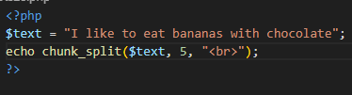
- You have a text. Delete al the whitespace trim(). Use count_chars and show the result. Then with the most used character, delete it from the original string. Show the result.
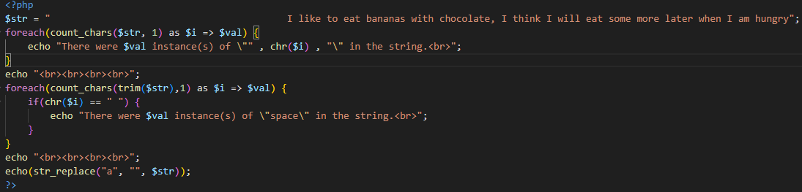
- Use explode() to cut a text of name of street to extract exclusively the names of the streets.
Example:
Input: calle uno,Calle dos,Calle leonardo Da Vinci, Calle Camino de Leganes, Calle final.
Output (Array):uno—dos—LeonardoDaVinci—CaminodeLeganes—Final.
Then use ucfirst() to put the first caracter in uppercase of each street name.
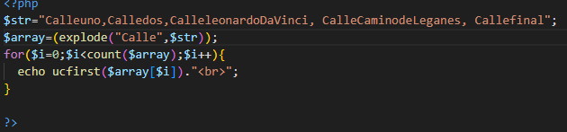

- Look up Jules Verne's bibliography on two different sites. Create 2 variables with two different bibliographys. The chronological list of his work.
Use the function similar_text() to calculate de similarity between two strings.
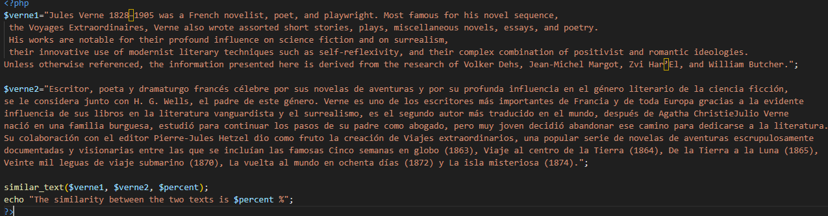
- You have a variable with the bibliography of Julio Verne.
- Check if an specific word exists in a text. str_contains.
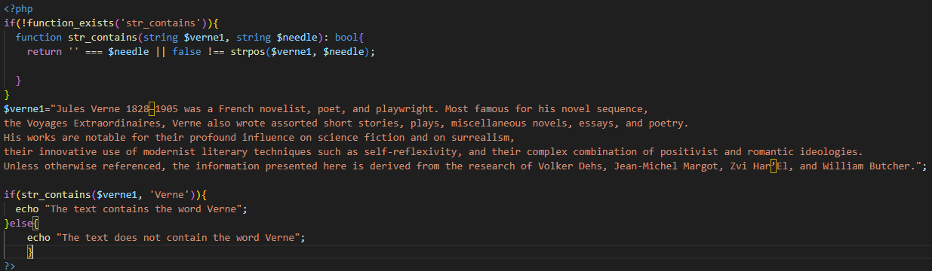
- Check if an specific word exists in a text and the position. str_pos
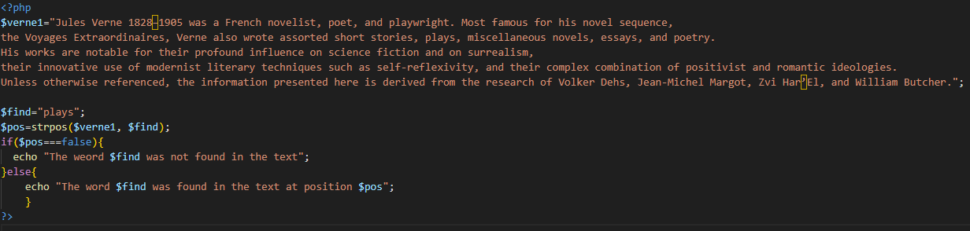
- Find the last occurrence of a word in a string. Strrchr
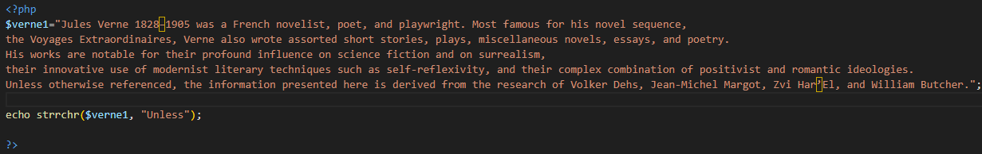
- Use strrev ¿What happened?
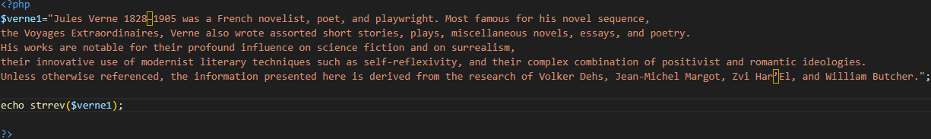

- Checks if a string ends with a given substring. str_ends_with
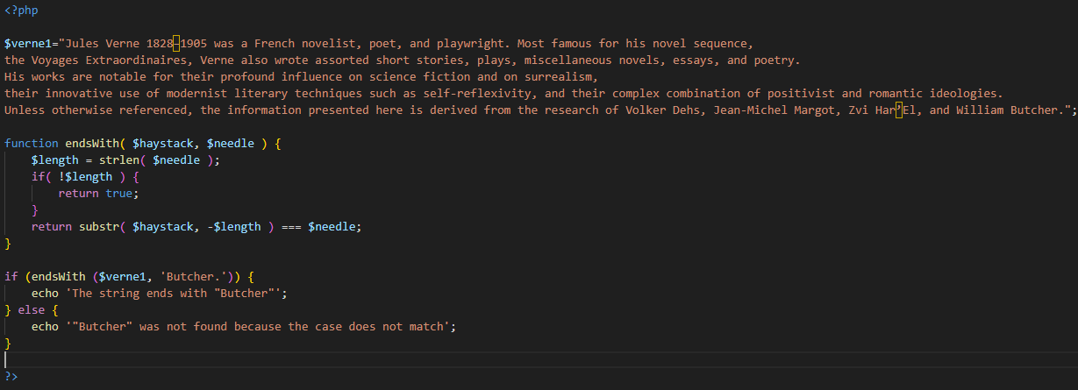
- Replace the “a” caracters for * in the string. str_replace or str_ireplace (differences?)
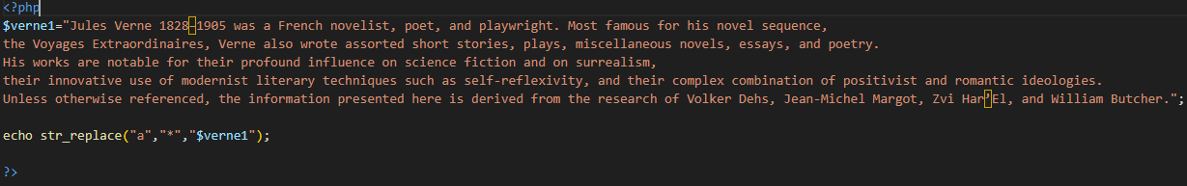
- Pad the text with the caracter “--” to a 1000 caracters, the same number of characters in the right and in the left. str_pad
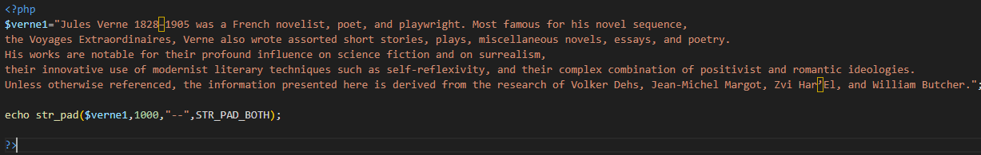
- Create the figure below using str_repeat
@#@#@#@#
/*/*/*/*/*/*
@~@~@~@~@
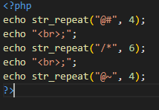
- Use str_shuffle to check the result after use in a text.
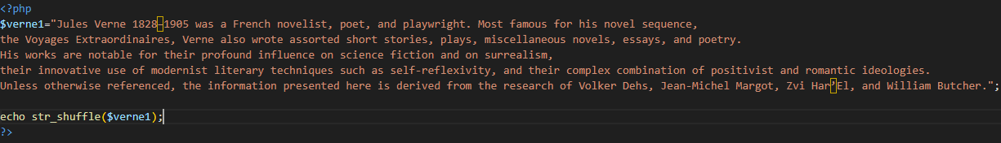
- With the variable of Julio Verne’s bibliografy use str_word_count to check the different uses with different values of parameter format
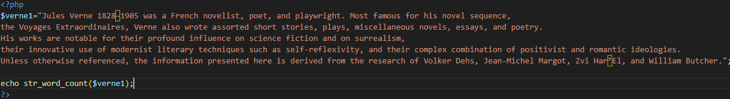
- Find the first position of a word in a text.
stripos
Repeat it by entering a search position (for example 10).
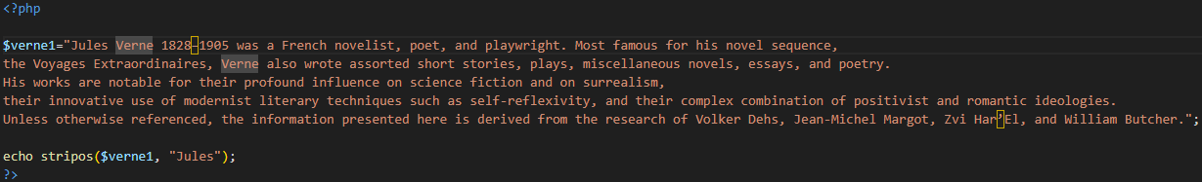
- Use strlen to know the number of characters.
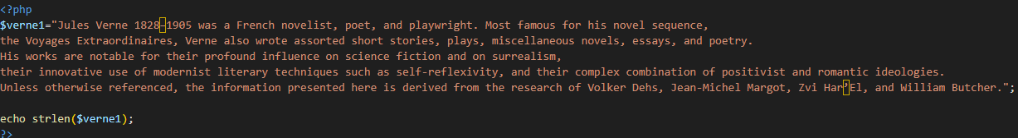
- You have a text in a variable. Use substr to have a string.
  - The last 20 characters.
  - The first 20 characters.
  - The first 20 characters starting from 10.
  - The last 20 characters starting from 10.
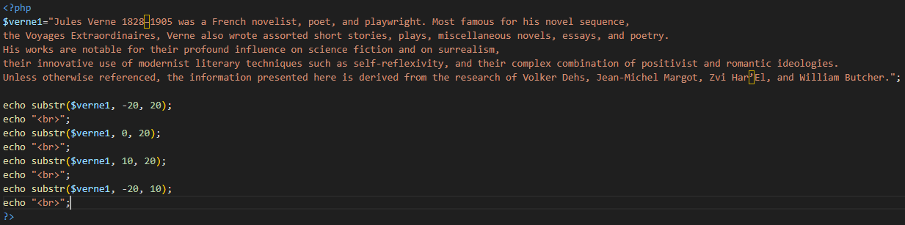
- You have a text in a variable. Use substr_count to know how many times a word appears.
